

**WEB TECHNOLOGIES**

**LAB-7**

**NAME:**

SUDANA SHASHI KIRAN

**REDG NUMBER:**

21BCE8644

**PROFFESOR:**

# DR. SHAIK KAREEMULLA

1. **Design a Registration page in HTML and CSS**
2. **Create a PHP page to read the data from form to PHP server program.**
3. **Create a script to a)create database b) create a table c) insert form data into table.**
4. **Fetch the user data from table and display in Html page.**

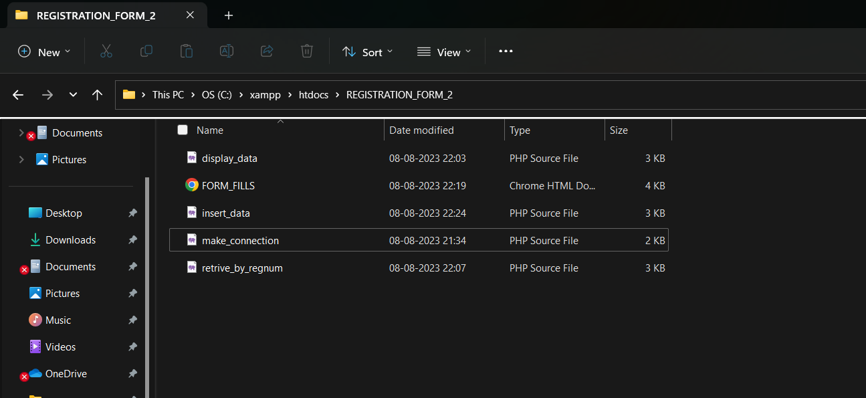 **1)FORMS_FILLS.html  
Code:**

**<**!DOCTYPE html>

<html>

<head>

<title>Registration Form</title>

<style>

body {

font-family: Arial, sans-serif;

background-color: #ffffcc;

margin: 0;

padding: 0;

color: #333;

}

.container {

background-color:#ff9999 ;

padding: 20px;

border-radius: 10px;

box-shadow: 0px 0px 10px rgba(0, 0, 0, 0.1);

max-width: 600px;

margin: 0 auto;

margin-top: 50px;

}

h1 {

text-align: center;

color: black;

padding: 20px 0;

}

form {

background-color: light blue;

padding: 30px;

border-radius: 10px;

box-shadow: 0px 0px 15px rgba(0, 0, 0, 0.1);

}

label {

display: block;

margin-bottom: 10px;

color: #555;

font-weight: bold;

}

input[type="text"],

input[type="email"],

input[type="date"],

input[type="tel"],

input[type="password"],

select,

textarea {

width: 100%;

padding: 12px;

margin-bottom: 20px;

border: 1px solid #ccc;

border-radius: 5px;

background-color: #ffffff;

color: #333;

}

select {

height: 38px;

}

textarea {

resize: vertical;

}

input[type="checkbox"] {

margin-right: 5px;

}

input[type="submit"] {

display: block;

margin: 20px auto;

padding: 12px 20px;

background-color: #007bff;

color: #fff;

border: none;

border-radius: 5px;

cursor: pointer;

font-size: 16px;

}

input[type="submit"]:hover {

background-color: #0056b3;

}

.name {

color: #007bff;

}

</style>

</head>

<body>

<h2>Name:Sudana shashi kiran <h2>

<h2>Registration number : 21BCE8644 <h2>

<div class="container">

<h2>Registration Form</h2>

<form action="insert_data.php" method="GET">

<label for="last_name">Last Name:</label>

<input type="text" id="last_name" name="last_name" required><br>

<label for="first_name">First Name:</label>

<input type="text" id="first_name" name="first_name" required><br>

<label for="reg_number">Registration Number:</label>

<input type="text" id="reg_number" name="reg_number" required><br>

<label for="email">Email ID:</label>

<input type="email" id="email" name="email" required><br>

<label for="dob">Date of Birth:</label>

<input type="date" id="dob" name="dob" required><br>

<label for="gender">Gender:</label>

<select id="gender" name="gender">

<option value="male">Male</option>

<option value="female">Female</option>

<option value="other">Other</option>

</select><br>

<label for="country">Country:</label>

<input type="text" id="country" name="country" required><br>

<label for="state">State:</label>

<input type="text" id="state" name="state" required><br>

<label for="pincode">Pincode:</label>

<input type="text" id="pincode" name="pincode" required><br>

<label for="mobile">Mobile Number:</label>

<input type="tel" id="mobile" name="mobile" required><br>

<label for="address">Address:</label>

<textarea id="address" name="address" rows="4" required></textarea><br>

<label for="password">Password:</label>

<input type="password" id="password" name="password" required><br>

<label for="reenter_password">Re-enter Password:</label>

<input type="password" id="reenter_password" name="reenter_password" required><br>

<input type="checkbox" id="terms" name="terms" required>

<label for="terms">I agree to the terms and conditions</label><br>

<input type="submit" value="Submit">

</form>

</body>

</html>  
 **Output:**

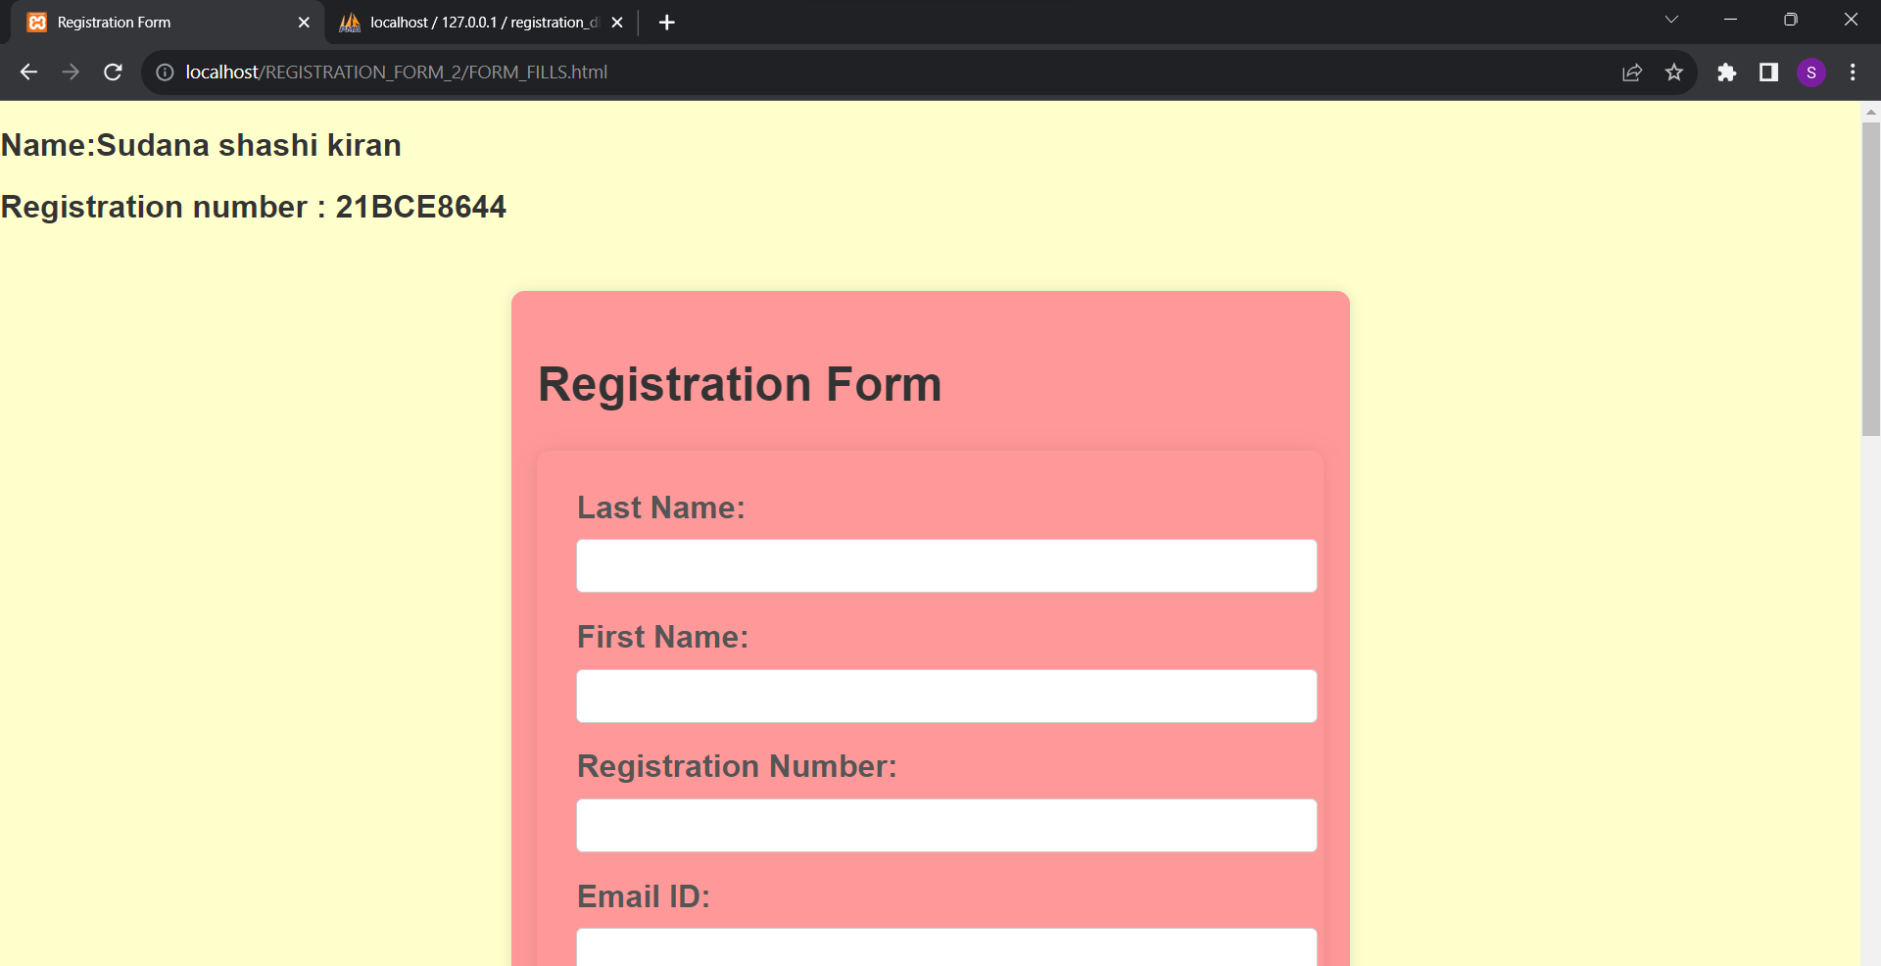

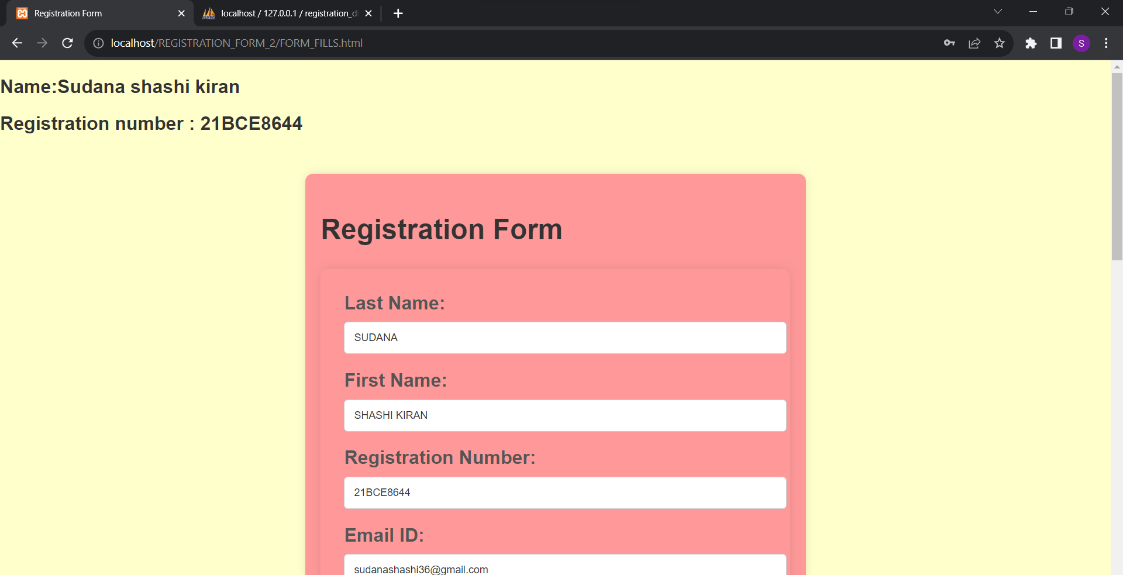

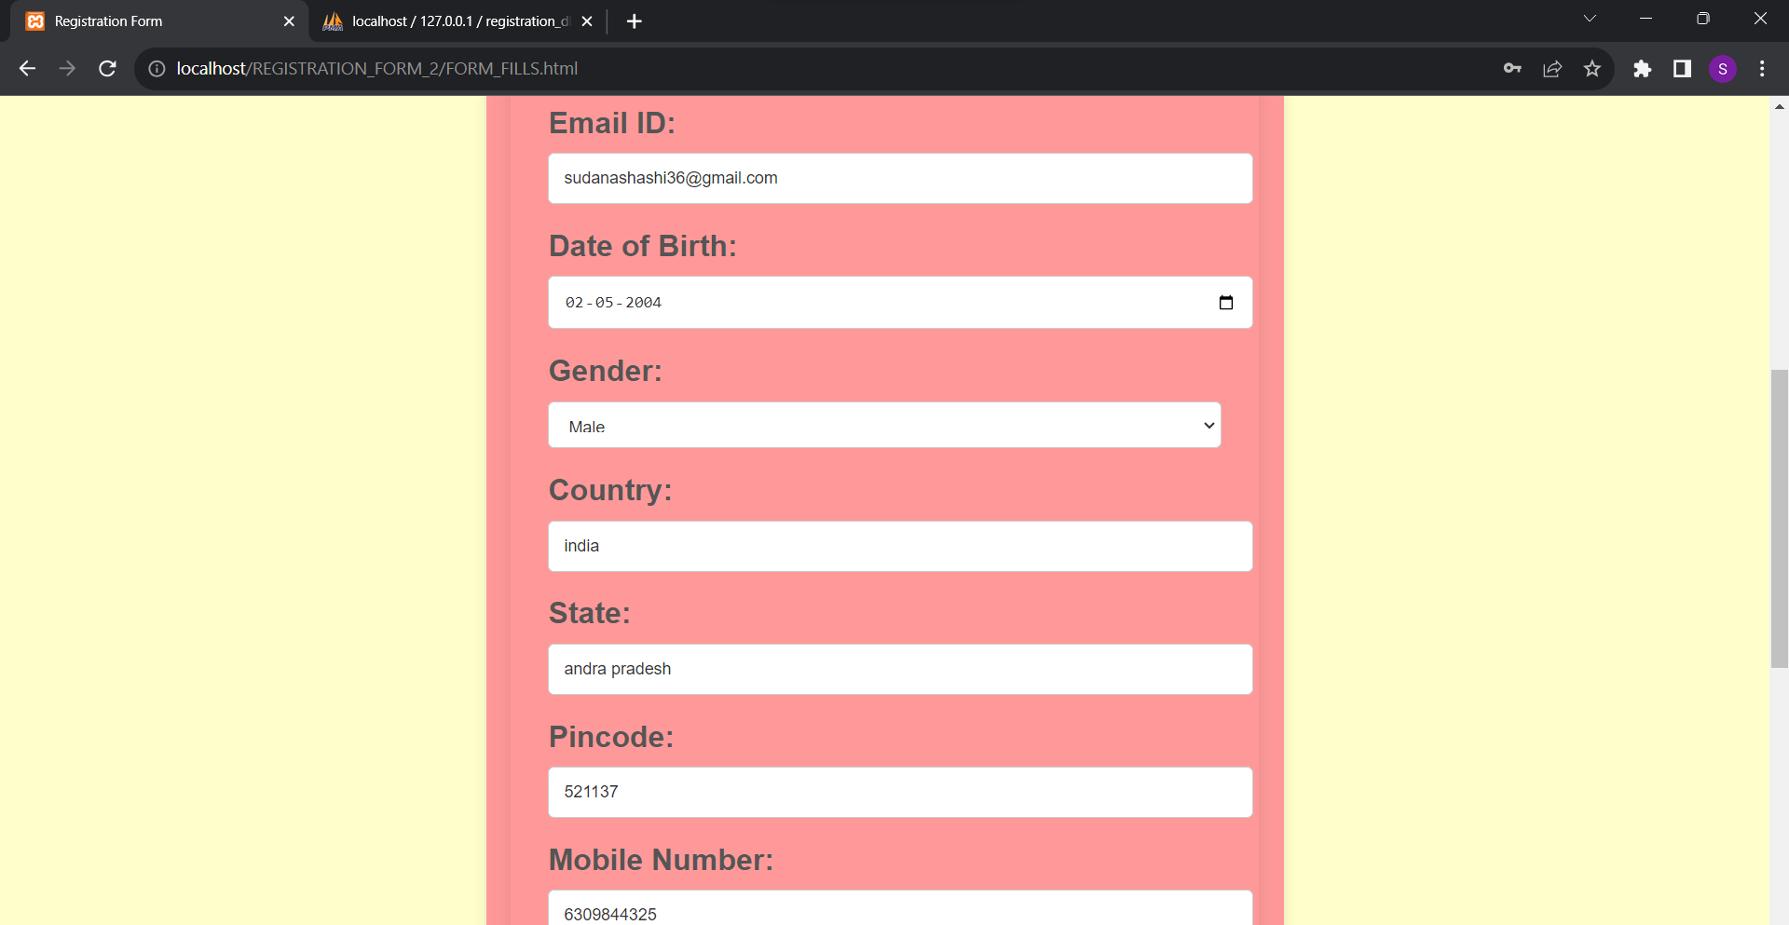

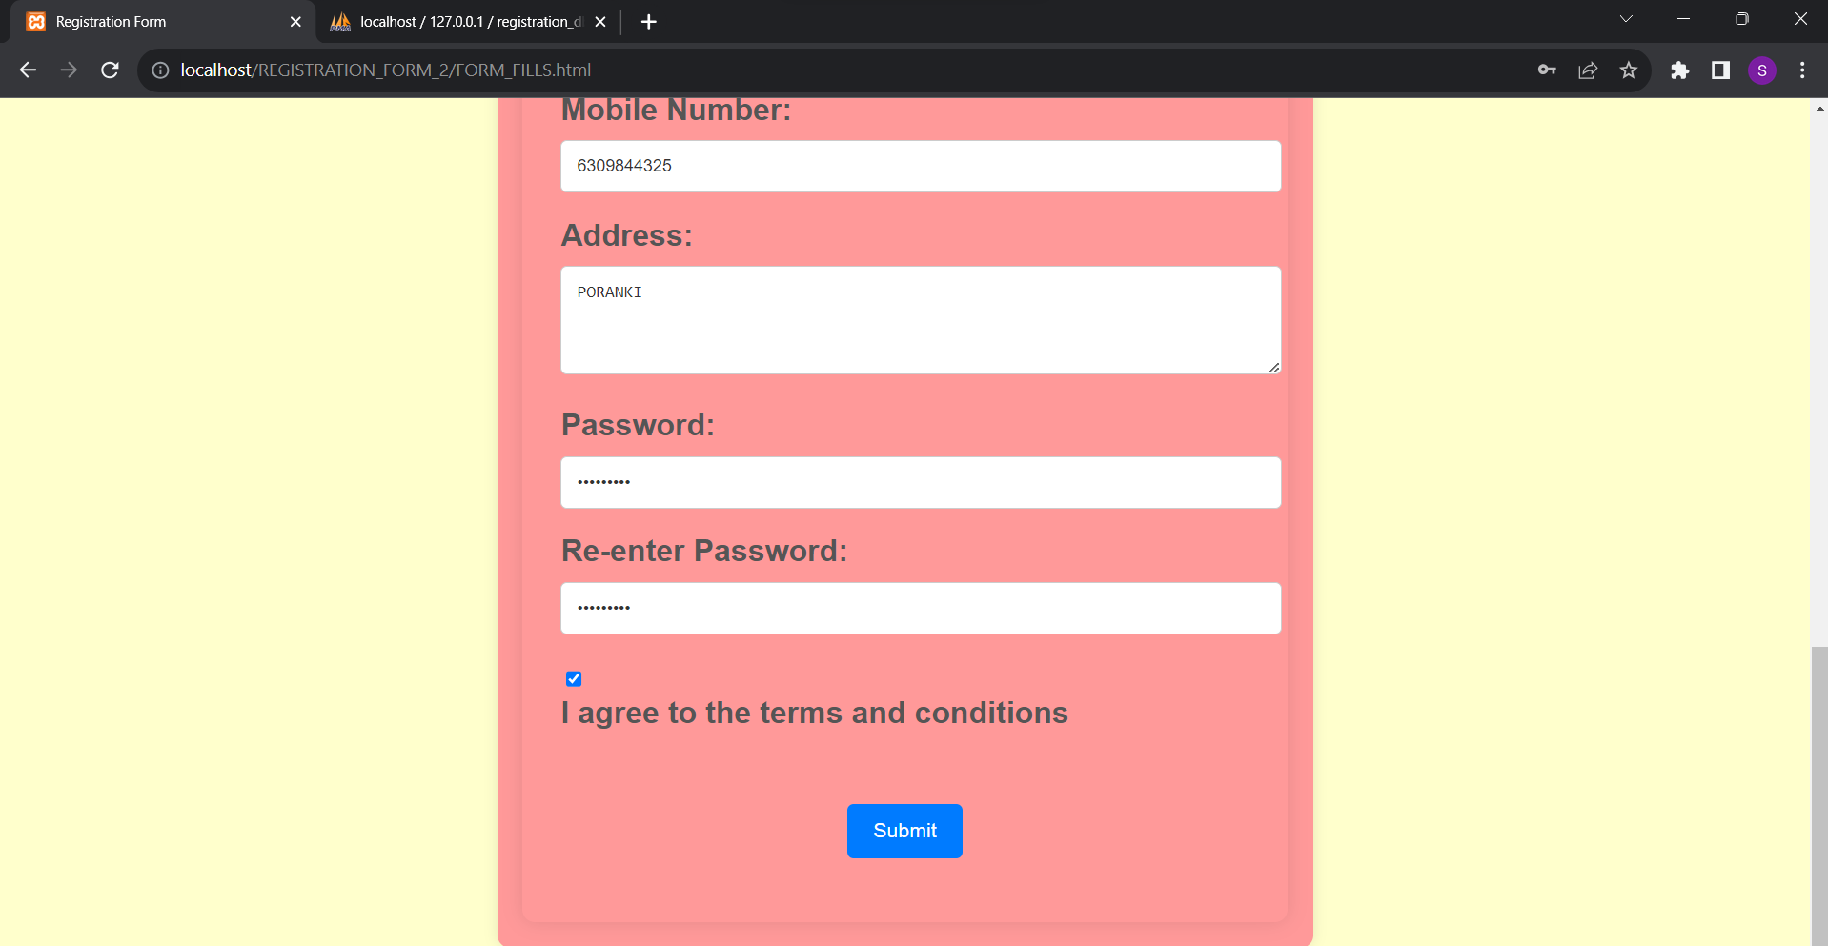  
  
  
  
  
  
  
  
  
  
  
  
  
  
2)**make_connection.php:**

**Code:**

<?php

$servername = "localhost";

$username = "root";

$password = "";

// Create connection

$conn = new mysqli($servername, $username, $password);

// Check connection

if ($conn->connect_error) {

die("Connection failed: " . $conn->connect_error);

}  
// Create database

$databaseName = "registration_db";

$createDatabaseSQL = "CREATE DATABASE IF NOT EXISTS $databaseName";

if ($conn->query($createDatabaseSQL) === TRUE) {

echo "Database created successfully.<br>";

} else {

echo "Error creating database: " . $conn->error . "<br>";

}// Select the created database

$conn->select_db($databaseName);

// Create table

$createTableSQL = "CREATE TABLE IF NOT EXISTS registrations (

id INT AUTO_INCREMENT PRIMARY KEY,

last_name VARCHAR(50) NOT NULL,

first_name VARCHAR(50) NOT NULL,

reg_number VARCHAR(20) NOT NULL,

email VARCHAR(100) NOT NULL,

dob DATE NOT NULL,

gender ENUM('male', 'female', 'other') NOT NULL,

country VARCHAR(50) NOT NULL,

state VARCHAR(50) NOT NULL,

pincode VARCHAR(10) NOT NULL,

mobile VARCHAR(15) NOT NULL,

address TEXT NOT NULL

)";

if ($conn->query($createTableSQL) === TRUE) {

echo "Table created successfully.<br>";

} else {

echo "Error creating table: " . $conn->error . "<br>";

}

?>  
  
**Output: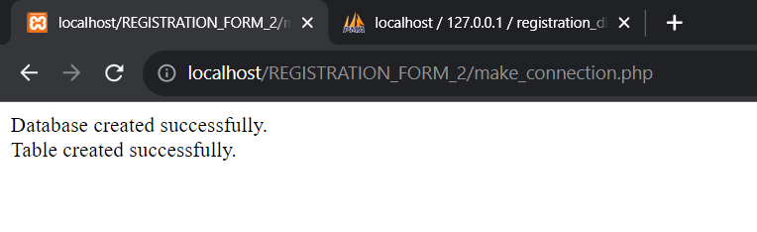 3)Insert_data.php:  
code:**

<!DOCTYPE html>

<html>

<head>

<title>DISPLAYING THE DATA </title>

<style>

body {

font-family: Arial, sans-serif;

background-color: #f0f0f0;

margin: 0;

padding: 0;

color: #333;

}

.container {

background-color: #ffffff;

padding: 20px;

border-radius: 10px;

box-shadow: 0px 0px 10px rgba(0, 0, 0, 0.1);

max-width: 1000px;

margin: 0 auto;

margin-top: 50px;

}

h2 {

align:center;

color: #007bff;

padding: 20px 0;

}

</style>

</head>

<body>

<div class="container">

<?php

$servername = "localhost";

$username = "root";

$password = "";

$databaseName = "registration_db";

$last_name = $_GET["last_name"];

$first_name = $_GET["first_name"];

$reg_number = $_GET["reg_number"];

$email = $_GET["email"];

$dob = $_GET["dob"];

$gender = $_GET["gender"];

$country = $_GET["country"];

$state = $_GET["state"];

$pincode = $_GET["pincode"];

$mobile = $_GET["mobile"];

$address = $_GET["address"];

// Reopen the connection for data insertion

$conn = new mysqli($servername, $username, $password, $databaseName);

// Check connection

if ($conn->connect_error) {

die("Connection failed: " . $conn->connect_error);

}

// Insert data into the table

$insertSQL = "INSERT INTO registrations (last_name, first_name, reg_number, email, dob, gender, country, state, pincode, mobile, address)

VALUES ('$last_name', '$first_name', '$reg_number', '$email', '$dob', '$gender', '$country', '$state', '$pincode', '$mobile', '$address')";

if ($conn->query($insertSQL) === TRUE) {

echo "Data inserted successfully.";

} else {

echo "Error inserting data: " . $conn->error;

}

echo "<p><strong>Last Name:</strong> $last_name</p>";

echo "<p><strong>First Name:</strong> $first_name</p>";

echo "<p><strong>Registration Number:</strong> $reg_number</p>";

echo "<p><strong>Email:</strong> $email</p>";

echo "<p><strong>Date of Birth:</strong> $dob</p>";

echo "<p><strong>Gender:</strong> $gender</p>";

echo "<p><strong>Country:</strong> $country</p>";

echo "<p><strong>State:</strong> $state</p>";

echo "<p><strong>Pincode:</strong> $pincode</p>";

echo "<p><strong>Mobile:</strong> $mobile</p>";

echo "<p><strong>Address:</strong> $address</p>";

// Close connection

$conn->close();

?>

</div>

</body>

</html> **Output:**

**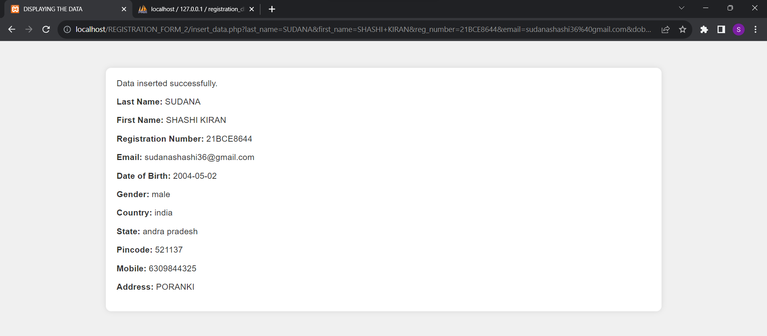  
  
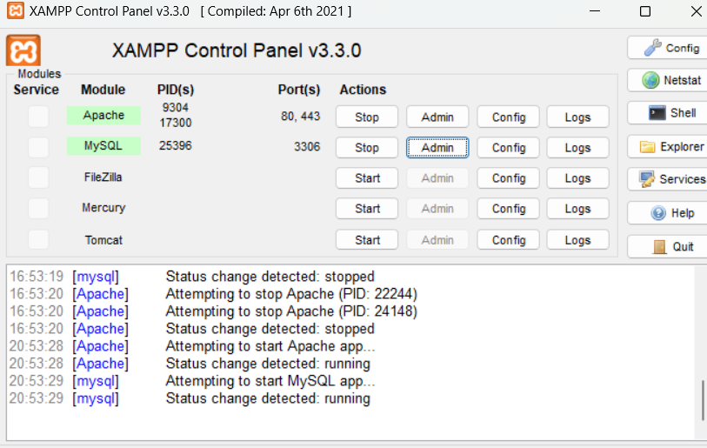  
  
  
watch out the data base in admin of mysql :**

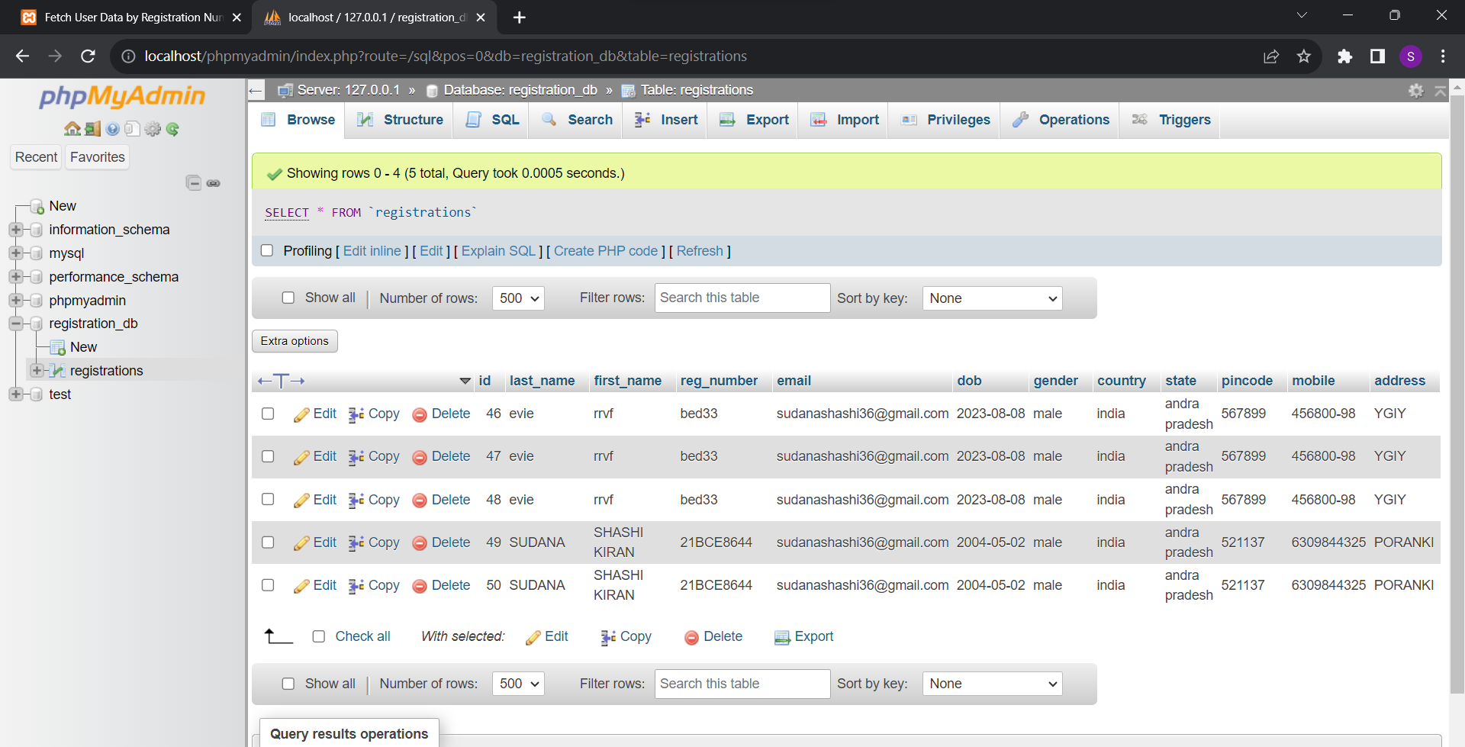  
  
  
  
  
  
  
  
**4)display_data.php:  
CODE:**  
<!DOCTYPE html>

<html>

<head>

<title>DISPLAYING THE DATA </title>

<style>

body {

font-family: Arial, sans-serif;

background-color: #f0f0f0;

margin: 0;

padding: 0;

color: #333;

}

.container {

background-color: #ffffff;

padding: 20px;

border-radius: 10px;

box-shadow: 0px 0px 10px rgba(0, 0, 0, 0.1);

max-width: 1000px;

margin: 0 auto;

margin-top: 50px;

}

h2 {

align:center;

color: #007bff;

padding: 20px 0;

}

</style>

</head>

<body>

<div class="container">

<?php

$servername = "localhost";

$username = "root";

$password = "";

$dbname = "registration_db";

// Create connection

$conn = new mysqli($servername, $username, $password, $dbname;

// Check connection

if ($conn->connect_error) {

die("Connection failed: " . $conn->connect_error);

}

// Fetch records from registrations table

$sql_select_records = "SELECT * FROM registrations";

$result = $conn->query($sql_select_records);

if ($result->num_rows > 0) {

echo "<h2>Records in REGISTRATION_DB</h2>";

echo "<table border='1'>

<tr>

<th>ID</th>

<th>Last Name</th>

<th>First Name</th>

<th>Registration Number</th>

<th>Email</th>

<th>Date of Birth</th>

<th>Gender</th>

<th>Country</th>

<th>State</th>

<th>Pincode</th>

<th>Mobile</th>

<th>Address</th>

</tr>";

while ($row = $result->fetch_assoc()) {

echo "<tr>

<td>".$row["id"]."</td>

<td>".$row["last_name"]."</td>

<td>".$row["first_name"]."</td>

<td>".$row["reg_number"]."</td>

<td>".$row["email"]."</td>

<td>".$row["dob"]."</td>

<td>".$row["gender"]."</td>

<td>".$row["country"]."</td>

<td>".$row["state"]."</td>

<td>".$row["pincode"]."</td>

<td>".$row["mobile"]."</td>

<td>".$row["address"]."</td>

</tr>";

}

echo "</table>";

} else {

echo "No records found.";

}

$conn->close();

?>

</div>

</body>

</html>  
**Output:**

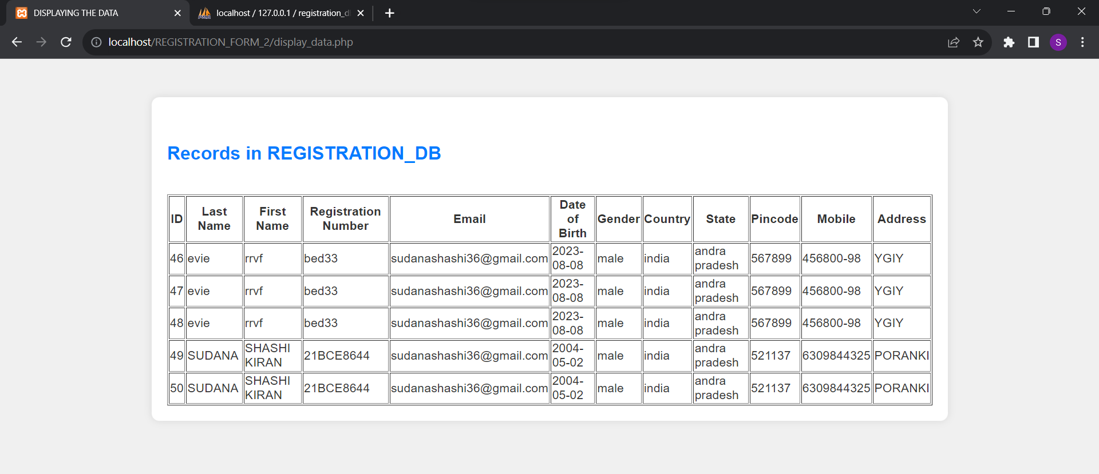

**5)retrive_by_regnum.php:  
CODE:**  
<!DOCTYPE html>

<html>

<head>

<title>Fetch User Data by Registration Number</title>

<style>

body {

font-family: Arial, sans-serif;

background-color: #f0f0f0;

margin: 0;

padding: 0;

color: #333;

}

.container {

background-color: #ffffff;

padding: 20px;

border-radius: 10px;

box-shadow: 0px 0px 10px rgba(0, 0, 0, 0.1);

max-width: 1000px;

margin: 0 auto;

margin-top: 50px;

}

h2 {

color: #007bff;

padding: 20px 0;

}

</style>

</head>

<body>

<h2>Fetch User Data by Registration Number</h2>

<form method="post">

<label for="registration_number">Enter Registration Number:</label>

<input type="text" id="registration_number" name="registration_number" required>

<input type="submit" value="Fetch Data">

</form>

<?php

$servername = "localhost";

$username = "root";

$password = "";

$dbname = "registration_db";

if ($_SERVER["REQUEST_METHOD"] == "POST") {

$registration_number = $_POST["registration_number"];

// Create connection

$conn = new mysqli($servername, $username, $password, $dbname);

// Check connection

if ($conn->connect_error) {

die("Connection failed: " . $conn->connect_error);

}

// Fetch user data by registration number

$sql_select_record = "SELECT * FROM registrations WHERE reg_number = '$registration_number'";

$result = $conn->query($sql_select_record);

if ($result->num_rows > 0) {

$row = $result->fetch_assoc();

echo "<h2>User Data for Registration Number: $registration_number</h2>";

echo "<p><strong>Last Name:</strong> " . $row["last_name"] . "</p>";

echo "<p><strong>First Name:</strong> " . $row["first_name"] . "</p>";

} else {

echo "<p>No records found for Registration Number: $registration_number.</p>";

}$conn->close();

}

?>

</body>

</html>  
  
**Output:**

